Grazioso Salvare Animal Rescue Dashboard
Samuel Harrison Parnell
CS-340 Client/Server Development
Southern New Hampshire University

Project Overview
The Grazioso Salvare Animal Rescue Dashboard is a full-stack application developed for Grazioso Salvare, an international rescue animal training organization. The purpose of the application is to help Grazioso Salvare identify dogs from the Austin Animal Center Outcomes dataset that may be suitable for specialized search-and-rescue training.
The application uses MongoDB as the database and a Python CRUD module to retrieve animal shelter records. A JupyterDash web application provides an interactive dashboard that allows users to filter the available animal records according to three rescue categories: Water Rescue, Mountain or Wilderness Rescue, and Disaster or Individual Tracking.
The dashboard provides an interactive data table, a breed chart, and a geolocation map. These components respond to the selected rescue filter and allow users to examine the animals that meet the criteria provided by Grazioso Salvare.

Required Functionality
The dashboard was developed to provide Grazioso Salvare with an intuitive interface for identifying potential rescue-training candidates. The completed application provides the following functionality:
- Retrieves animal shelter records from MongoDB through a Python CRUD module.
- Displays the animal records in an interactive data table.
- Allows users to filter records by rescue type.
- Provides filtering options for:
  - Water Rescue
  - Mountain or Wilderness Rescue
  - Disaster or Individual Tracking
  - Reset
- Dynamically updates the data table when a rescue type is selected.
- Displays a bar chart showing the most common breeds in the filtered results.
- Provides a geolocation map showing the location of a selected animal.
- Allows users to sort and paginate the data table.
- Includes the Grazioso Salvare logo.
- Includes a unique identifier containing the developer's name.
The filtering criteria were based on the preferred breeds, sex, and training-age requirements provided in the Dashboard Specifications Document.

Dashboard Testing and Functionality
The completed dashboard was tested by running the application and applying each of the required filtering options. The following screenshots demonstrate the functionality of the application.

Starting State
The starting state displays the complete animal shelter dataset along with the rescue-type filtering options, interactive data table, breed chart, and geolocation map.
Figure 1. Dashboard Starting State
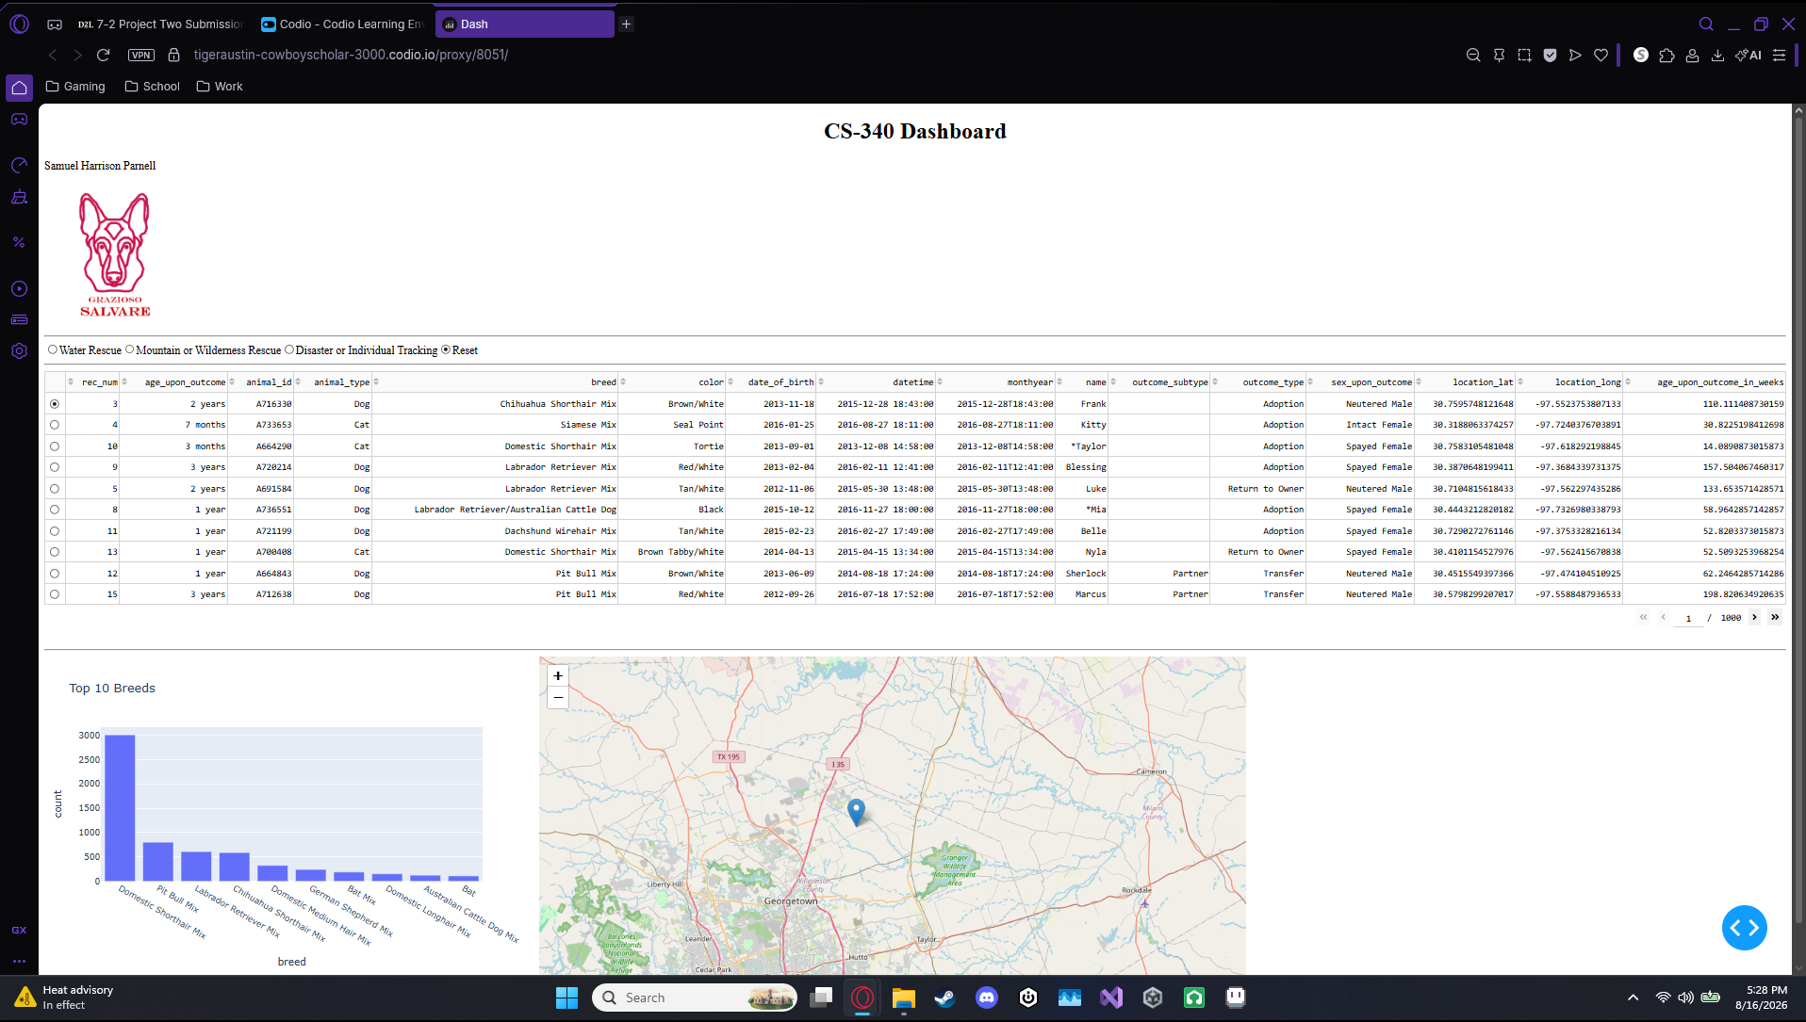
The dashboard initially loads with the Reset option selected. The data table contains the unfiltered animal shelter records, while the chart and map provide information based on the available table data.

Water Rescue
The Water Rescue filter searches for dogs that meet the specified Water Rescue requirements. These requirements include the preferred Water Rescue breeds, an intact female sex, and an age between 26 and 156 weeks.
Figure 2. Water Rescue Filter
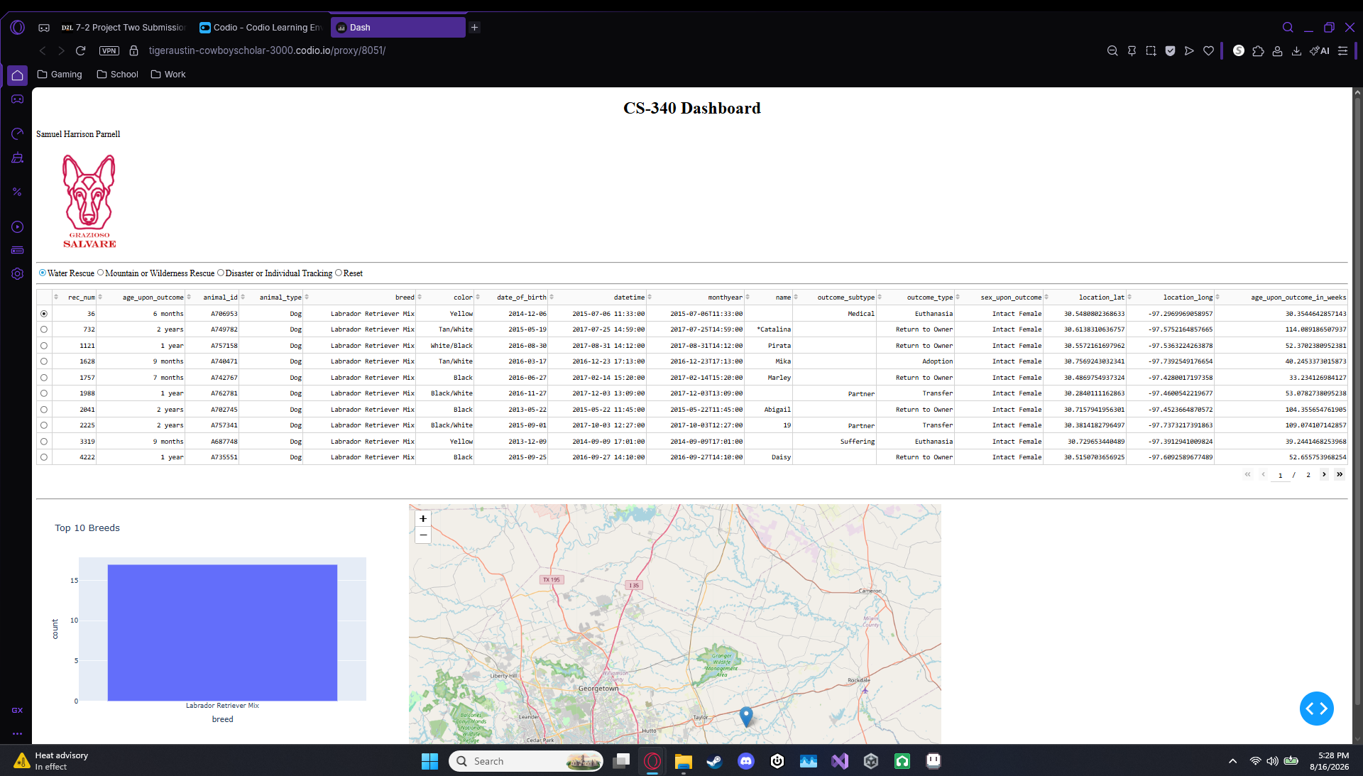
After selecting Water Rescue, the data table updates to display only records matching the specified criteria. The breed chart also updates to reflect the filtered records, and the geolocation component remains available for examining individual animals.

Mountain or Wilderness Rescue
The Mountain or Wilderness Rescue filter identifies dogs that meet the specified requirements for this type of rescue. The criteria include the preferred Mountain or Wilderness Rescue breeds, an intact male sex, and an age between 26 and 156 weeks.
Figure 3. Mountain or Wilderness Rescue Filter
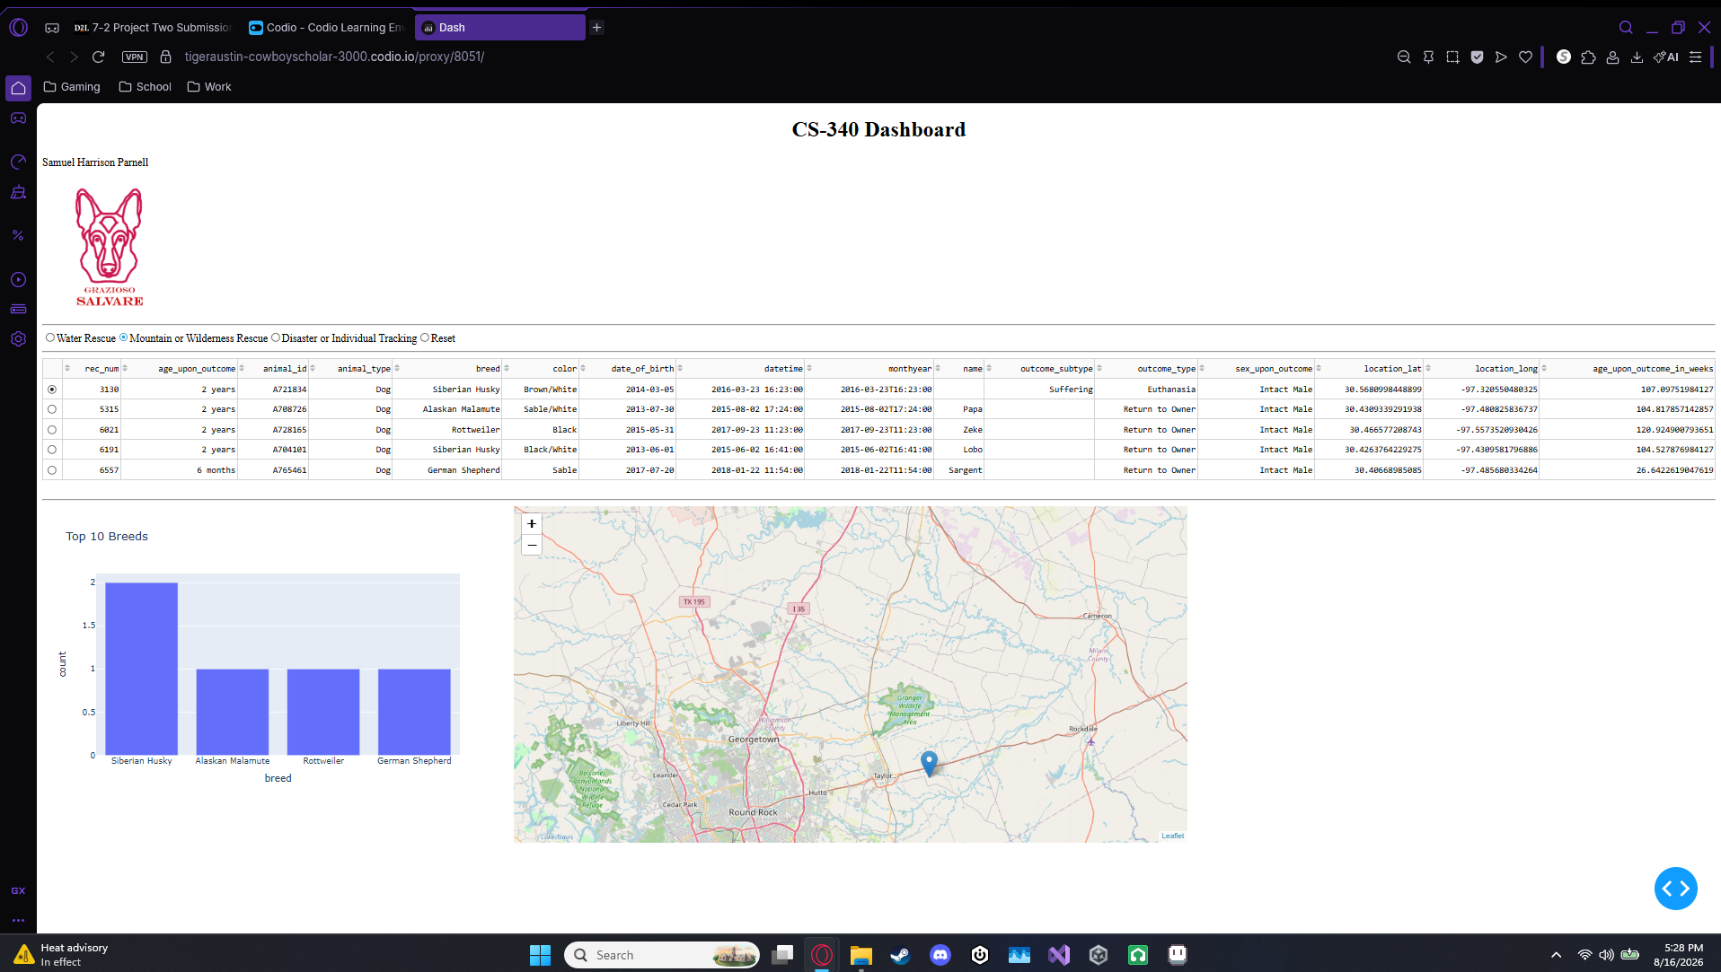
The dashboard dynamically updates after the filter is selected. The table displays only qualifying records, and the chart updates based on the filtered dataset.

Disaster or Individual Tracking
The Disaster or Individual Tracking filter identifies dogs that meet the requirements for disaster response or individual tracking. The criteria include the preferred breeds, an intact male sex, and an age between 20 and 300 weeks.
Figure 4. Disaster or Individual Tracking Filter
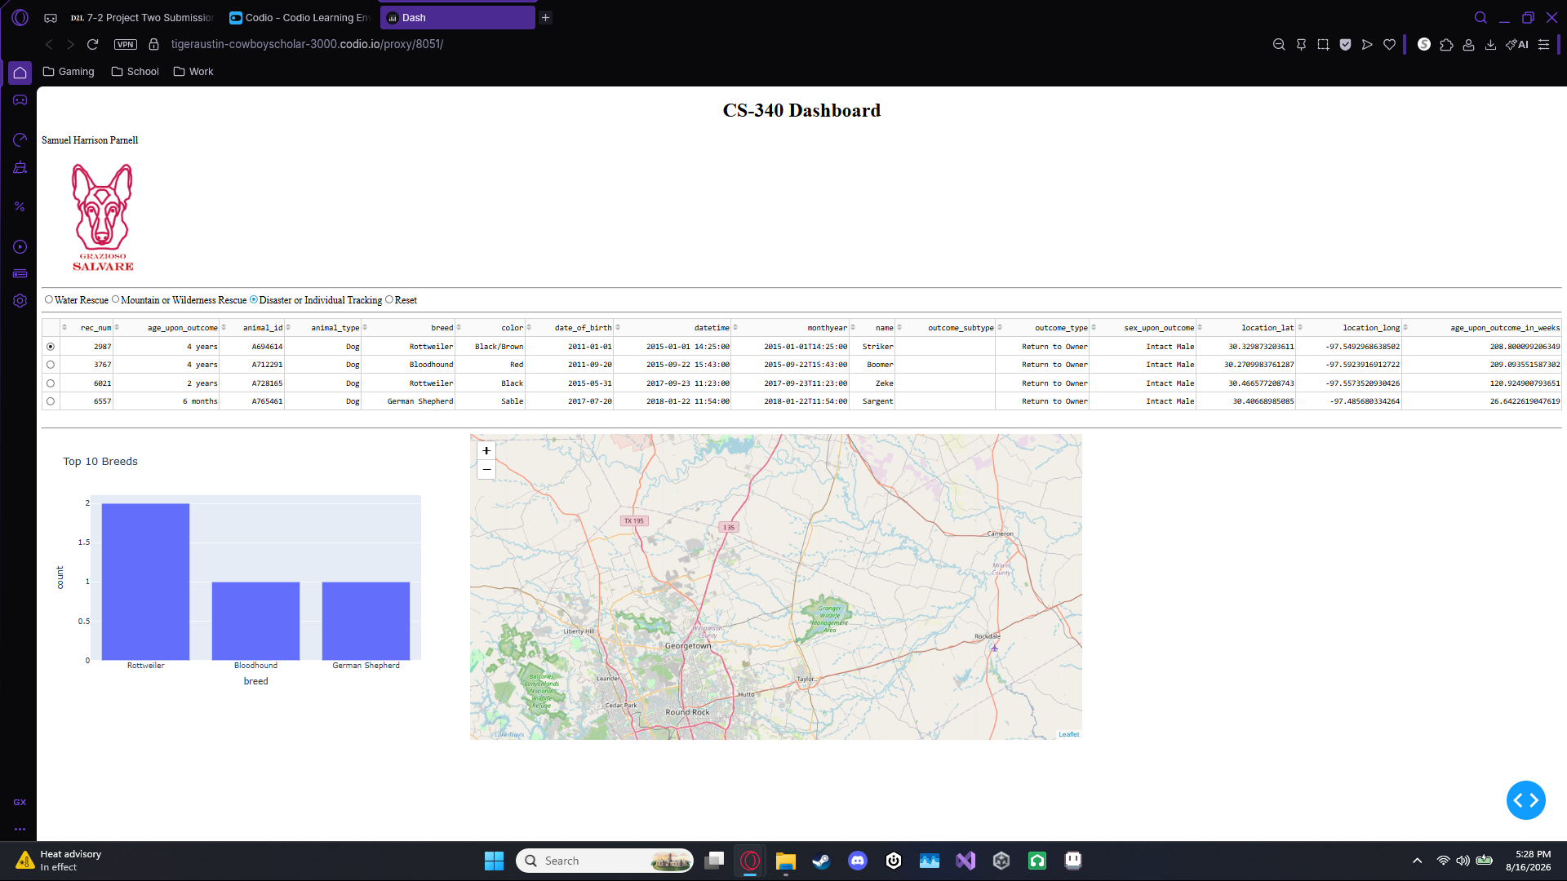
The dashboard updates the table and chart based on the matching records. Users can also select an individual record in the table to view its location on the geolocation map.

Reset
The Reset option returns the dashboard to its original unfiltered state.
Figure 5. Reset Filter
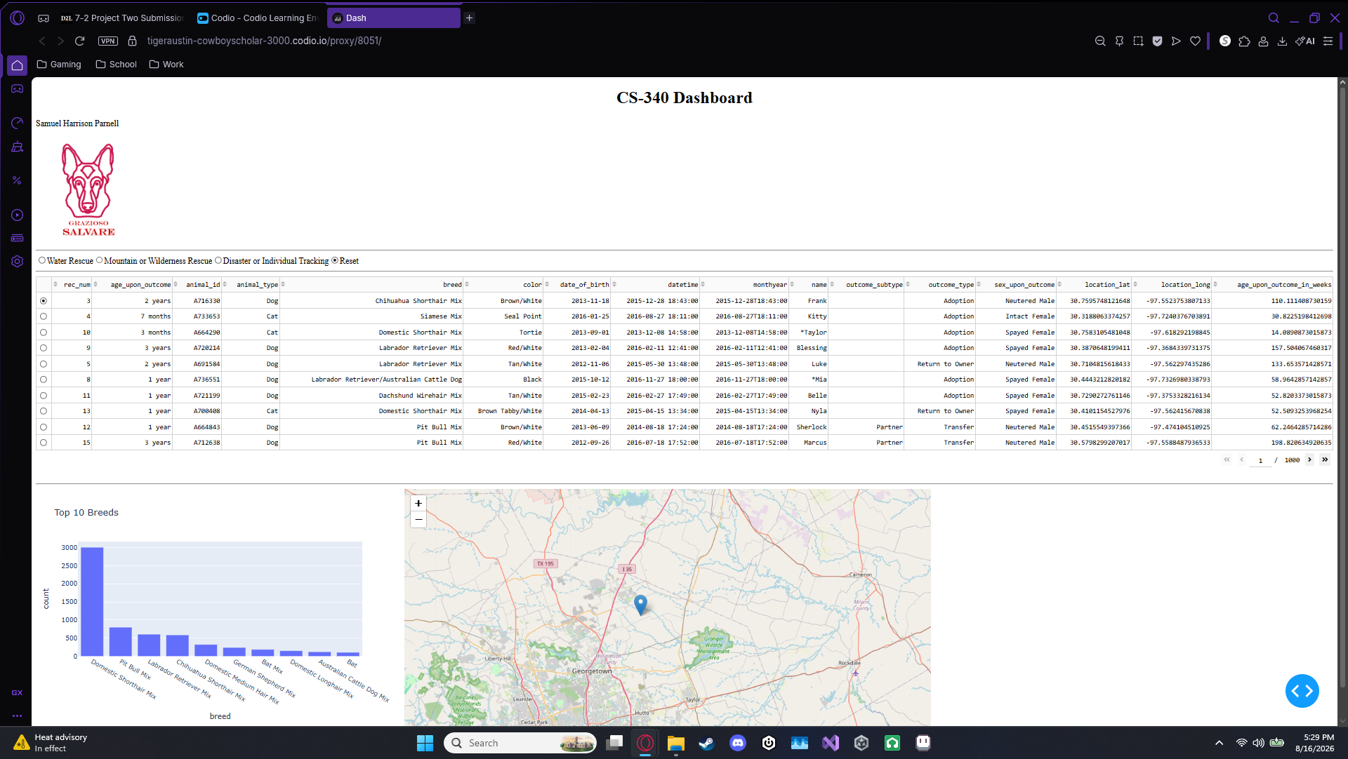
Selecting Reset removes the rescue-specific filtering criteria and retrieves the complete animal shelter dataset from MongoDB.

Tools and Technologies
Several technologies were used to develop the Grazioso Salvare dashboard. Each technology was selected based on its ability to support the application's database, data-processing, and user-interface requirements.

MongoDB
MongoDB was used as the model component of the application's MVC design. MongoDB is a document-oriented NoSQL database that stores records as flexible documents. This makes it appropriate for the Austin Animal Center dataset because the animal records can be stored and queried using their individual fields.
MongoDB also works effectively with Python through the PyMongo library. PyMongo allows Python applications to establish database connections and perform operations such as retrieving, inserting, updating, and deleting documents. The project uses these capabilities through the “AnimalShelter” CRUD Python module.
MongoDB was also useful for this project because the dashboard needed to perform filtered queries based on multiple fields. Queries using operators such as “$in”, “$gte”, and “$lte” allowed the application to identify records matching the rescue requirements.

Python
Python was used as the primary programming language for the database interface and dashboard application. Python provides libraries for connecting to MongoDB, manipulating datasets, creating visualizations, and developing web applications.
The “AnimalShelter” class created during Project One provides the database interface used by the dashboard. The dashboard calls the module's “read()” method to retrieve records from MongoDB.

PyMongo
PyMongo provides the connection between Python and MongoDB. The CRUD module uses MongoClient to establish a connection to the MongoDB server and provides methods for interacting with the “animals” collection.
Using PyMongo allowed the dashboard to retrieve filtered records directly from MongoDB rather than storing a separate copy of the dataset in the application.

Dash and JupyterDash
Dash was used to create the client-facing web dashboard. JupyterDash allows the Dash application to run within the Jupyter environment used for this project.
Dash provides the view and controller components of the MVC design. Dashboard elements such as radio buttons, tables, charts, and maps make up the user interface, while Dash callbacks control how those components respond to user input.
For example, selecting a rescue type triggers a callback that sends the appropriate query to MongoDB through the CRUD module. The resulting records are then displayed in the data table and used to update the chart and map.

Pandas
Pandas was used to convert MongoDB query results into DataFrames. DataFrames make it easier to manipulate and analyze the returned animal records before displaying them through the dashboard.
Pandas was also used to calculate the number of records associated with each breed for the dashboard's breed chart.

Plotly
Plotly was used to create the dashboard's interactive breed chart. The application uses a bar chart to display the ten most common breeds represented in the currently filtered dataset.
Because the chart receives the filtered table data, it updates automatically when the user selects a different rescue type.

Dash Leaflet
Dash Leaflet was used to create the geolocation component of the dashboard. The map uses the latitude and longitude information associated with the selected animal to display a marker showing its location.
The map also provides additional information about the selected animal through a tooltip and popup.

Project Development Process
The project was completed in several stages.
First, the Austin Animal Center Outcomes dataset was imported into MongoDB. The database was configured with the “aac” database and “animals” collection.
Next, the “AnimalShelter” Python class developed during Project One was used to provide CRUD functionality for the MongoDB collection. The dashboard uses the “read()” method from this module to retrieve animal records.
The initial dashboard was then created using the provided “ProjectTwoDashboard.ipynb” starter file. The application first retrieved all animal records and displayed them in a data table.
Interactive filtering options were then added using Dash radio buttons. MongoDB queries were developed for each of the three rescue categories using the preferred breeds, sex, and training-age requirements supplied by Grazioso Salvare.
The data table was modified to respond to the selected filtering option. Pagination, sorting, and row selection were added to make the table easier for the client to use.
A dynamic breed chart was then created using Plotly. The chart receives the filtered table data and displays the ten most common breeds.
The geolocation map was implemented using Dash Leaflet. Selecting an animal in the table allows the map to display the corresponding animal's location.
Finally, the Grazioso Salvare logo and developer's unique identifier were added to the dashboard. The application was tested using each of the required filtering options and the Reset option.

Challenges and Solutions
Several challenges were encountered during development and testing of the dashboard.

MongoDB ObjectID
One issue occurred because MongoDB can return an “_id” field containing an ObjectID for each document. Dash's data table cannot directly display these ObjectID values.
This was resolved by checking whether “_id” was present in the DataFrame and removing it before passing the records to the dashboard.
if '_id' in df.columns:
df.drop(columns=['_id'], inplace=True)
This allowed the remaining animal information to be displayed correctly.

Database Connection
During testing, the dashboard initially returned no records. The problem was ultimately traced to the MongoDB credentials being used by the CRUD module. After correcting the password for the “aacuser” account, the dashboard successfully retrieved approximately 10,000 animal records.
This confirmed that the dashboard and CRUD module were successfully communicating with MongoDB.

Dashboard Port
While testing the JupyterDash application, port 8050 was already being used by another running application. This caused the dashboard to return an "Address already in use" error.
The issue was resolved by running the application on port 8051 instead:
app.run_server(port=8051)

Geolocation Map Index
The geolocation map initially produced an “IndexError” when there was no selected row or when the filtered dataset was empty. The callback was modified to check whether data or a selected row was available before attempting to access the DataFrame.
This prevented the application from attempting to access a row that did not exist.

Reproduction Instructions
The following steps can be used to reproduce the project.

1. Set up MongoDB
Install and configure MongoDB and create the “aac” database with an “animals” collection containing the Austin Animal Center Outcomes dataset.

2. Configure the database user
Create the “aacuser” MongoDB account with the appropriate permissions to access the “aac” database.

3. Obtain the project files
The project requires the following files:
- ProjectTwoDashboard.ipynb
- CRUD_Python_Module.py
- Grazioso Salvare Logo.png
The CRUD Python module and dashboard notebook should be located in the same project directory.

4. Install the required Python packages
The project requires Python packages including:
- JupyterDash
- Dash
- Dash Leaflet
- Plotly
- Pandas
- PyMongo
- NumPy
- Matplotlib
These packages can be installed using Python's package manager.

5. Configure the database credentials
Open ProjectTwoDashboard.ipynb and provide the correct MongoDB username and password:
username = "aacuser"
password = "password"
The password should not be committed to a public GitHub repository.

6. Run the dashboard
Open ProjectTwoDashboard.ipynb in JupyterLab and run the notebook.
The dashboard will run using the configured JupyterDash server port.

7. Test the filters
After the dashboard loads, test each of the following:
- Reset
- Water Rescue
- Mountain or Wilderness Rescue
- Disaster or Individual Tracking
The table and charts should update when each filter is selected.

8. Test the map
Select an individual animal from the data table. The geolocation map should display a marker corresponding to that animal's location.

Resources
The following resources and documentation were used during development:
- MongoDB documentation — database and query functionality
- PyMongo documentation — Python interface for MongoDB
- Dash documentation — dashboard components and callbacks
- Plotly documentation — interactive data visualization
- Dash Leaflet documentation — interactive maps
- Pandas documentation — DataFrame and data manipulation functionality
- Jupyter documentation — notebook development environment

Conclusion
The completed Grazioso Salvare Animal Rescue Dashboard provides an interactive interface for identifying dogs that meet specific search-and-rescue training requirements. MongoDB serves as the application's data model, while the Python CRUD module provides the database interface. Dash and JupyterDash provide the interactive dashboard components and controller logic.
The completed application allows Grazioso Salvare users to filter the animal shelter dataset by rescue type, examine qualifying animals in an interactive table, visualize breed information through a dynamic chart, and examine animal locations using the geolocation map. Testing demonstrated that the dashboard successfully responds to all required rescue filters and can be returned to its original state using the Reset option.

